**Module 1: Linux System**

**Content of course**

1. Download Syllabus.
2. Lab setup.
3. Download and Install Virtual Machine.
4. Creating First Virtual Machine.
5. Linux Installation
6. Command syntax for Linux.
7. Files and directory permissions and ownership.
8. Gelling help.
9. Tab and up arrows.
10. Pipes (|).
11. Adding text to files.
12. File display commands.
13. File maintenance commands.
14. Filter and text processing commands (wc,grep,egrep,awk,cut,etc)
15. Combining and splitting files.
16. Linux Vs windows commands.
17. Linux file editor (VI).
18. User account management.
19. Switch Users and sudo commands.
20. System utility commands.
21. Process and Jobs.
22. Process and jobs.
23. Process management.
24. System Monitoring commands.
25. Log monitoring.
26. System maintenance commands.
27. Changing hostnames.
28. Finding System information.
29. Getting system architecture information.
30. Terminal commands.
31. Terminal Ctrl Keys.
32. Recovering root password.

Oracle Virtual Box Download and installation

* Browse on Oracle Virtual Box then download.
* Install it.
* Create First Virtual Machine.

Linux download and installation.  [CentOS-7-x86_64-DVD-1908.iso](http://ftp.iij.ad.jp/pub/linux/centos-vault/7.7.1908/isos/x86_64/CentOS-7-x86_64-DVD-1908.iso) download

Which be Anaconda is an installation program used by CentOS.

Software selection is “Server with GUI”

* Software config.

Kdump is a kernel crash dumping mechanism designed for saving the system's memory contents for later analysis. It is especially helpful for the purposes of debugging when you want to discover the cause of a crash.

* Linux CentOS 8 installation.

[CentOS-8-x86_64-1905-dvd1.iso](http://ftp.iij.ad.jp/pub/linux/centos-vault/centos/8.0.1905/isos/x86_64/CentOS-8-x86_64-1905-dvd1.iso) Download

Security policy not fall under the localization tab in Linux CentOS 8

* User settings and configuration.

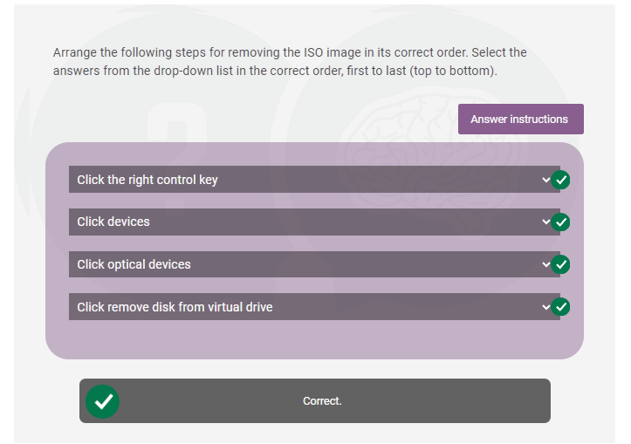

**On successful completion of this module you will be able to:**

* Explain the function of Oracle Virtual Box.
* Define the different system tabs in Linux CentOS 8.
* Discuss the process of creating a virtual machine.
* Describe the role of the Anaconda installation program in CentOS 8.

Module Summary

**In this module you learned:**

* The Oracle Virtual Box is a platform that allows users to run multiple operating systems on the same hardware.
* A file system is a logical collection of files on a partition or disk. A partition is a container for information and can span an entire hard drive if desired.
* The right control key is used to release the mouse from the installation screen on Windows.
* The installation program that Cent OS uses is known as Anaconda.
* VDI is the recommended hard disk file type to use when creating your first Oracle virtual machine.
* The options that fall under the system tab in Linux CentOS 8 are:

1. KDUMP option
2. Security Policy option
3. Network and Host Management option
4. Installation Destination option